Knock Sensor Controller (KSC3)
Engine Knock Detection System

Contents
Contents 2
Disclaimer 4
Introduction 5
KSC is supplied with: 5
Not Included 5
Set Up 5
Wiring 6
Connector Pin Plan - (photo of connector below) 6
Pin List 7
Wiring Notes 8
The KSC Android App 8
Pairing KSC to Android device 8
Configuring KSC with Android App - Overview 8
Sensor Inputs 9
Load Threshold 9
Resolution 10
RPM 10
Knock Sensor Signal Gain 10
Setting Up The Unit 11
RPM 11
Save Volume 11
Find Knock Frequency - Knock ID Tool 11
How to use the Knock ID tool. 12
Setting the Knock Frequency 13
Setting the Knock Volume Threshold 13
3-Level Knock Indication Output 14
About Level Indications 15
Optimising Ignition Timing with Visual Indication and Output to Engine ECU 15
Audio Knock Detection 15
More Information 15

Disclaimer

WARNING
MoviChip products should be used for motorsport and/or off-highway use only.
MoviChip products should only be used by persons who are experienced with automotive electrical and mechanical systems and the effects of altering such systems.
Misuse or improper tuning of MoviChip products can cause unexpected vehicle behaviour and/or failure (temporary or permanent) of existing vehicle systems e.g. limp mode, engine damage etc.
MoviChip products are universal. It is the responsibility of the end user to ensure MoviChip products are suitable for their specific application. MoviChip is not responsible for special, incidental or consequential damages or costs incurred due to the failure of this product.

MoviChip products are used entirely at the risk of the end user.

Introduction
The MoviChip KSC is a knock detection system designed for automotive use. The KSC is a tool to help the calibrator identify the optimum ignition timing. The KSC is not a device which is designed to compensate for a bad tune/calibration.
The KSC can integrate with 12 volt and 5 volt circuits. The 12 volt signal is used to power the LED strip light to alert the driver to knock in real time. The 5 volt signal can integrate with compensation tables in an engine ECU to retard ignition timing and/or increase fuel and/or close DBW (for example) when engine knock is detected by the KSC3.

KSC is supplied with:
The KSC unit
Main unit connector with crimps terminals & boot. User makes their own wiring loom.
Build sheet detailing software and hardware versions and password for Bluetooth connection.
Instruction manual can be downloaded from the MoviChip website, it is not sent with the product.
The Android app can be downloaded from the MoviChip website.
Knock Sensor
Knock Sensor Connector with Terminals
LED Strip

Not Included
Wires (User makes their own loom)

Set Up
To get the KSC up and running there are five main steps.
1.Build the wiring loom and wire unit into car.
2.Pair KSC to Android device first. And then install KSC app onto Android device.
3.Check the wiring using the in-built test function in the app.
4.Identify the knock frequency window for the engine using the Knock ID tool in the KSC Android app.
5. Identify the engine's normal (no knock) knock signal level, in the knock frequency window, for the entire RPM range.
6.Set our knock signal threshold.
This manual will go through each of these five steps.

Wiring
Unit can be mounted in engine bay but away from sources of heat and moisture.

Connector Pin Plan - (photo of connector below)
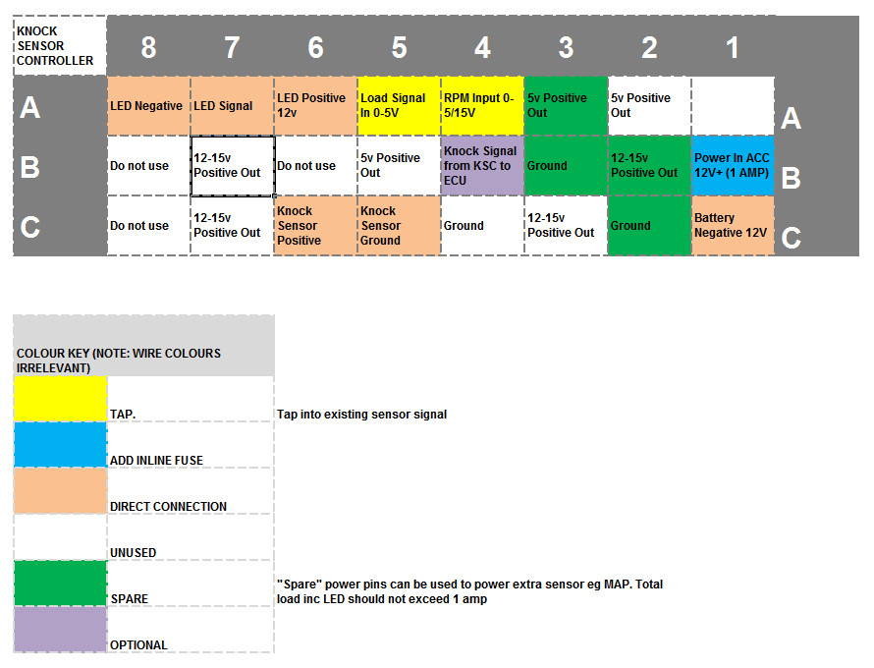

Figure 1 - Looking at connector from wiring/loom side
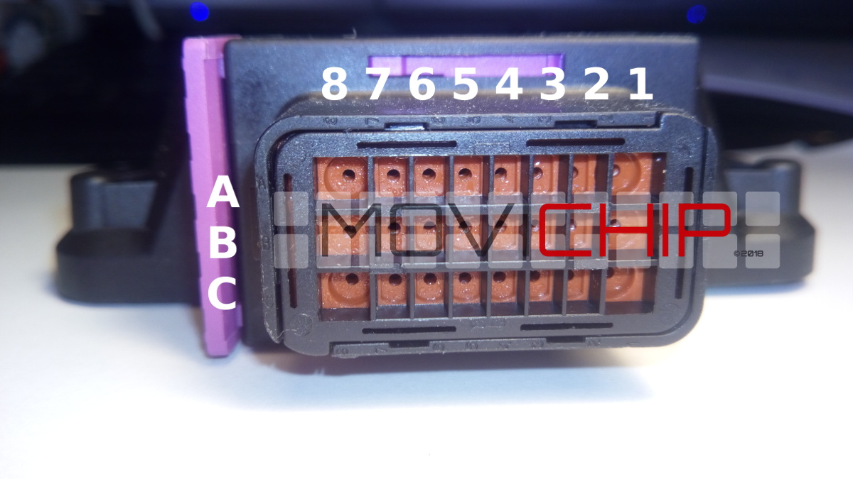
Figure 2 - Around the holes where we insert the wire into the connector, the columns and rows are marked/indented into the plastic. Characters are small.

Wiring Notes
B1 - Power Positive 12v - Input (Powered when ignition on)
B5 - Bridge to A5 *if* Load Signal is not required
The RPM signal should alternate between 0 volts and 5 to 15 volts
Power inputs should be fused as detailed above.
Knock sensor should be connected directly to KSC and not spliced to other ECUs. If knock sensor signal is spliced to other ECUs it may cause interference and improper functioning and detection of knock.
Load signal should be TPS or MAP
Use the Test function (click "Knock") in the app to confirm wiring is correct. Sensor input data will be shown in app. LED will alternate in colour, Blue to Orange to Red. 0-5v signal will be sent to engine ECU in three steps. Note down these voltages for use in correction/compensation table. Click "No Knock" to turn off test mode.

The KSC Android App
The Android app is where we program the KSC unit.

Pairing KSC to Android device
First we need to pair the KSC to your Android device.
After wiring in the KSC3 unit to the car. With ignition on, open the settings menu of your Android device, go to Bluetooth settings, add new device, when KSC3 shows, pair your device with the KSC3 unit. Password for the KSC3 unit will be written on the build sheet included with the KSC3.
Now we can download the KSC app from the MoviChip website. Use the software version written on your build sheet.

Configuring KSC with Android App - Overview
Download the Android App from the MoviChip website.
To setup the KSC3 we use the KSC app to configure the settings. This is the process:
1.We calibrate/check the connections of the knock sensor input, MAP input and RPM signal
2.We setup the unit to use the Knock ID and Baseline tools
3.Identify the knock frequency. We use the Knock ID tool to identify/confirm the knock frequency, as read by the knock sensor, for the specific engine
4.Identify baseline volume. We use the Baseline Configuration tool to identify the normal knock sensor signal volume when engine is not knocking.
5.We confirm our settings are not outputting false positives and we confirm our settings are not missing knock events. If unit is not identifying knock to the accuracy required, we tune our settings (knock frequency window monitored and/or volume threshold) to achieve accuracy required.
The steps below are listed in order.
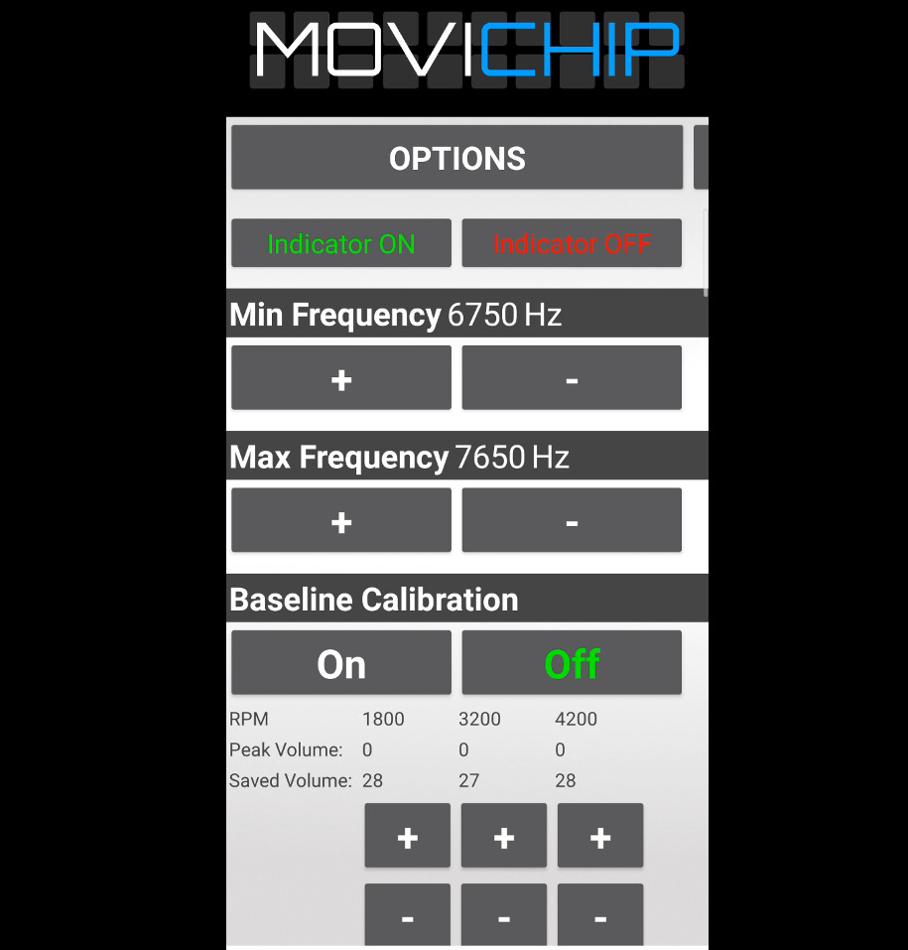
Figure 3 - A snap shot of the KSC Android app

Sensor Inputs
We need to calibrate/check the sensor inputs. We can see live sensor reading by clicking "Knock" in the "Test" section of the app.
If we simply want to populate the stored values already in the unit we press "Off" in the "Baseline Calibration" section.
NOTE: Pressing "On" will reset the RPM points. A new calibration run will need to be done. Setup procedure is detailed below.

Load Threshold
The KSC3 has a Load Threshold setting. This is used to ignore knock signals that occur below the set load threshold. The purpose of this feature is to stop the KSC3 from outputting a knock signal when the throttle is lifted. This setting is optional. Use it if you think you need to. Start by setting the threshold to the minimum. Tune the setting when you are familiar with the KSC3.

Resolution
The KSC3 has two resolution settings for detecting knock. Normal and High. Choose the setting that works best for you. Start with Normal and go from there.

RPM
Are we getting one signal per revolution on our RPM signal or 0.5 (1 signal every two revolutions of the engine). We enter the number.
This signal should alternate between 0 volts and 5 to 15 volts.
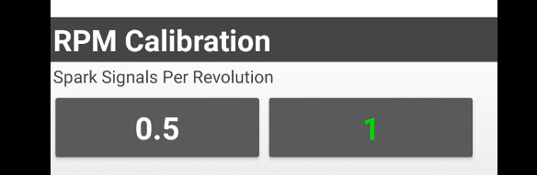
Figure 4 - Number of signals we get per RPM

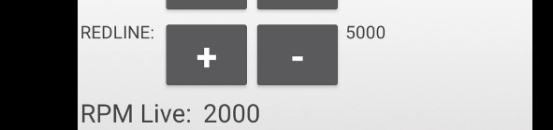
Figure 5 - We can verify RPM is correct by pressing the "Knock" button in the "Test" section of the app.
.

Knock Sensor Signal Gain
Set to Std is recommended. Alternatively carry out a full throttle pull while monitoring "Live K Sensor" if the highest number is regularly exceeding 900, using "Low" setting maybe beneficial. Generally we find Std is fine.
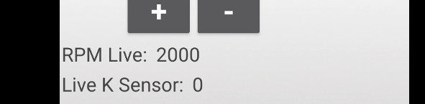
Figure 6 - If the "Live K Sensor" number exceeds 900 regularly in a full throttle pull, "Low" setting can be used but generally we recommend "Std"
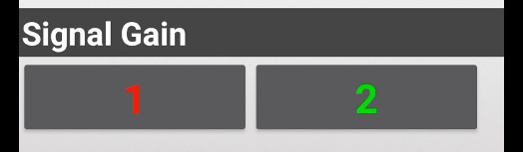
Figure 7 - Use Low setting if Knock signal is too high (>900 regularly).

Setting Up The Unit
Before we can use the inbuilt apps to identify the knock frequency and volume, we need to choose some settings.

RPM
We need to choose a mid RPM and the redline RPM. Redline RPM is self explanatory. It is recommended to choose an RPM slightly lower than redline eg if redline is 7000rpm, redline could be set as 6500rpm. Mid RPM point will be somewhere around 50% of the rev range. If the engine has an 8000 rpm redline, we set this value to around 4000 rpm. You can adjust these RPM numbers to suit your preferences.
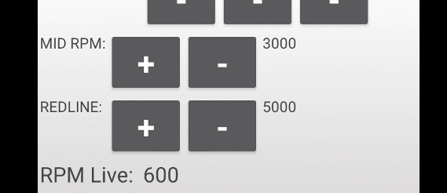

Save Volume
This is the knock volume threshold. During the set up process we want to be able to hear (light, non-damaging) engine knock without the KSC interfering with the engine ECU. We can either disconnect the KSC from the ECU and/or we set the Saved Volumes to very high numbers.
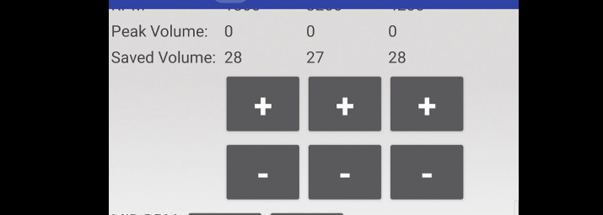

Find Knock Frequency - Knock ID Tool
To identify knock we first must know the knock frequency. There are two methods to find the knock frequency. The first is to use a Knock Frequency Calculator and then verify that frequency using an audio knock frequency detector.
The second method is to use the Knock ID tool inside the KSC Android app and then verify that frequency using an audio knock frequency detector.
A guide to making your own audio knock detector is given below

How to use the Knock ID tool.
1.In the engine ECU, set a conservative/retarded ignition timing over an RPM band. We suggest 2000-3000rpm. We want the ignition timing at this RPM band to conservative so we can guarantee that the engine will not be knocking at high/full load.
2.Record the volumes of the knock frequency bands by driving with a high/full load between 2000 and 3000 rpm. We record the runs by pressing "On" on the app before starting the run and pressing "Off" before finishing.
Press "Off" on the app to stop recording.
Ideally, we want to stop recording before the throttle is lifted.
3.Repeat this process 3-5 times. At the end of each run, when pressing "Off", the tool will output the frequency segments and the maximum volume recorded.
NOTE: There will be a delay of around 3 seconds between pressing "Off" and the list being populated. If the list does not populate, press Off again and wait 3 seconds. Repeat this until the line is populated, if necessary.
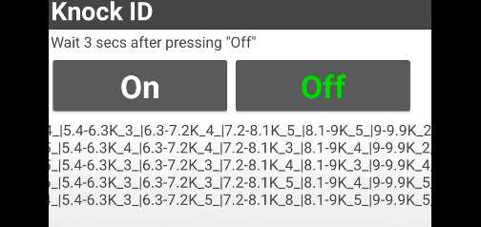
Figure 8 - Knock ID output. Each line represents one run.
4.Repeat the process, without switching the engine off, but this time with the ignition timing advanced to cause slight, non-damaging knock between 2000 and 3000 rpm, at light throttle.
5.Look through the runs (compare the lines to those where ignition was retarded) and identify the frequency segments whose volume has changed between the runs with retarded ignition and advanced ignition timing. This will indicate the knock frequency of the engine. This will normally be close to the theoretical knock frequency of the engine.
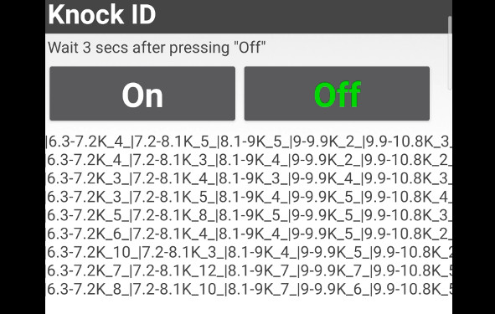
Figure 9 - Comparing runs with ignition timing retarded vs advanced. 6.3-7.2K & 7.2-8.3K have jumps in volume. Theoretical knock frequency is 7.2k. We will set frequency window at 6.7k minimum and 7.6k maximum.

Setting the Knock Frequency
When we have identified the knock frequency we need to enter the values into the app.
Minimum and maximum frequency should match the frequency segment found using the Knock ID tool. It is recommended to give a broad frequency range until you are familiar with the product.
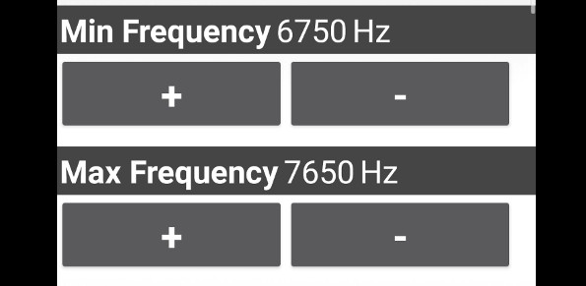
Figure 10 - Setting the knock frequency window to be monitored

Setting the Knock Volume Threshold
To set the threshold we need to know what is a normal volume for the engine in the frequency window set in the previous step. We measure this using the "Baseline" tool inside the app.
1.Set a conservative ignition timing map for high/full load for the entire rev range of the engine
2.Press "On" in "Baseline Calibration". Do a run from around 1000 rpm at high/full load to redline rpm. Record the run by pressing "On" and finish recording (before lifting the accelerator) by pressing Off. This will output the peak volume at three RPM points through the rev range. The RPM points are drawn from the mid-point and redline RPM numbers we entered earlier.
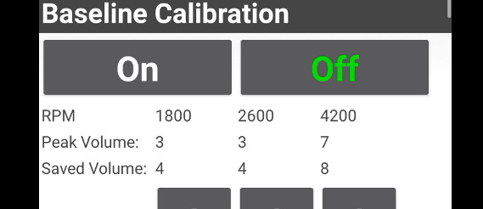
Figure 11 - Baseline output shows max volume @ 1800 RPM as 3, 2600 RPM as 3 and 4200 RPM as 7. We set our thresholds (“Saved Volume”) just above these values.
3.We set the Saved Volume to numbers slightly higher than the peak numbers we have just recorded.
4.We should verify the thresholds we have just entered by repeating the run (with the same ignition timing). We should not receive any warning signals coming from the KSC. If we do we should either tune the knock frequency and/or the volume thresholds we have entered.
5.When we are happy we are not getting false positives, we return the engine ignition timing map back to normal.
Confirm volume threshold. We increase the ignition timing at a set RPM to induce slight knock. We then check that the KSC is detecting the knock (it sends a signal to the LED and/or ECU). If it does not, tune the threshold volume and or the frequency window we are monitoring.
The KSC is now ready to detect knock.
We can now close the app by pressing the red bar at the bottom.
We only need to use the app again if we want to adjust the settings entered above.

3-Level Knock Indication Output
The KSC3 has two, three-level outputs to indicate knock.
The first is a three level visual indication displayed via a LED light. Level 1 knock is blue, level 2 is orange, level 3 is red.
The second is a 3 level voltage signal. This is intended to be fed to the engine ECU for use in a compensation table eg when 1 volt is received ignition retards by 1 degree. Level 1 (Blue colour from LED) is indicated by 0.9v*, Level 2 (Orange) is indicated by 2.4v* and Level 3 (Red) is indicated by 4.9v*.
*Approximate values, enabling to "Test" function and logging the input in the engine ECU will give the actual value.
It's highly recommended to set the correction/compensation table to maximum safety at the lowest signal from the KSC3 and increase as you get a feel for how the KSC3 is performing. eg set all Level Indications to minus 8 degrees and gradually reduce the timing retard for Level 1 & 2 as you get used to how the KSC3 performs.
IMPORTANT: The knock indication outputs are activated for either 0.5 seconds or three seconds (depending on the user setting) when the KSC detects knock. If the KSC3 detects knock during this period, the KSC3 will increase the Level Indication up to Level 3 or until the knock stops.
Which Indication Period to Choose?
Choose whichever period works for your situation.

About Level Indications
The knock Indication Level has nothing to do with how dangerous the engine knock is. Level 1 could cause engine destruction. The different levels indicate how far above the knock volume threshold the detected knock is. Blue (Level 1) is above the threshold. Orange (Level 2) is knock more above the threshold than Blue. Red (Level 3) is the most above the threshold.

Optimising Ignition Timing with Visual Indication and Output to Engine ECU
An example of how to use the visual indication and the output to the engine ECU to optimise ignition timing.
We have Level 1 indication retarding ignition timing by 1 degree. Level 2 by 3 degrees and Level 3 by 8 degrees
If we are consistently seeing the LED flash blue (Level 1 indication) and not orange (Level 2 indication) at a certain load and RPM, this suggests that reducing timing by 1 degree is enough to quell the knock in these conditions.
Alternatively if we are seeing an orange indication but not red, this suggest that reducing ignition timing by 2 or 3 degrees could quell knock in these conditions. Assume three degrees and work from there.

Audio Knock Detection
It is essential to audibly monitor engine knock during the setup process of the KSC3.
One method is to use a dedicated knock sensor connected to the mic input of the laptop. APO Equaliser (free software from SourceForge) can filter out frequencies that are not knock. VLC Player (Free software) lets us listen to the input in close to real time through headphones. A knock sensor with 3.5mm jack is available to order with the KSC3.

More Information
Check the product page on the MoviChip website for more information including videos on the KSC

