Knock Sensor Controller (KSC)
Engine Knock Detection System

Contents
Contents 2
Disclaimer 3
Introduction 4
Wiring 5
The KSC Android App 5
Sensor Inputs 6
RPM 6
Knock Sensor Signal 7
Setting Up The Unit 7
RPM 7
Save Volume 8
Knock ID 8
How to use the Knock ID tool. 8
Setting the Knock Frequency 9
Setting the Knock Volume Threshold 10

Disclaimer

WARNING
MoviChip products should be used for motorsport and/or off-highway use only.
MoviChip products should only be used by persons who are experienced with automotive electrical and mechanical systems and the effects of altering such systems.
Misuse or improper tuning of MoviChip products can cause unexpected vehicle behaviour and/or failure (temporary or permanent) of existing vehicle systems e.g. limp mode, engine damage etc.
MoviChip products are universal. It is the responsibility of the end user to ensure MoviChip products are suitable for their specific application. MoviChip is not responsible for special, incidental or consequential damages or costs incurred due to the failure of this product.

MoviChip products are used entirely at the risk of the end user.

Introduction
The MoviChip KSC is a knock detection system designed for automotive use. The KSC is a tool to help the calibrator identify the optimum ignition timing. The KSC is not a device which is designed to compensate for a bad tune/calibration.
The KSC can integrate with 12 volt and 5 volt circuits. The 12 volt signal can be used with lights and/or buzzers to alert the driver to knock in real time. The 5 volt signal integrates with an ECU so ignition timing can be retarded when engine knock is detected.
To get the KSC up and running we first have to wire the unit into the car. Secondly we have to enter the settings relevant for your engine using the KSC Android app which should be downloaded from the MoviChip website

Wiring
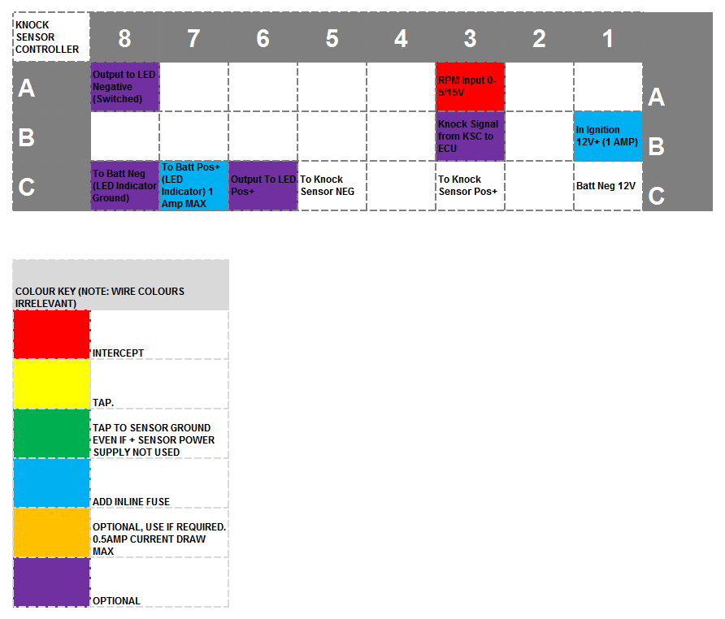
Figure 1 - Looking at connector from wiring/loom side
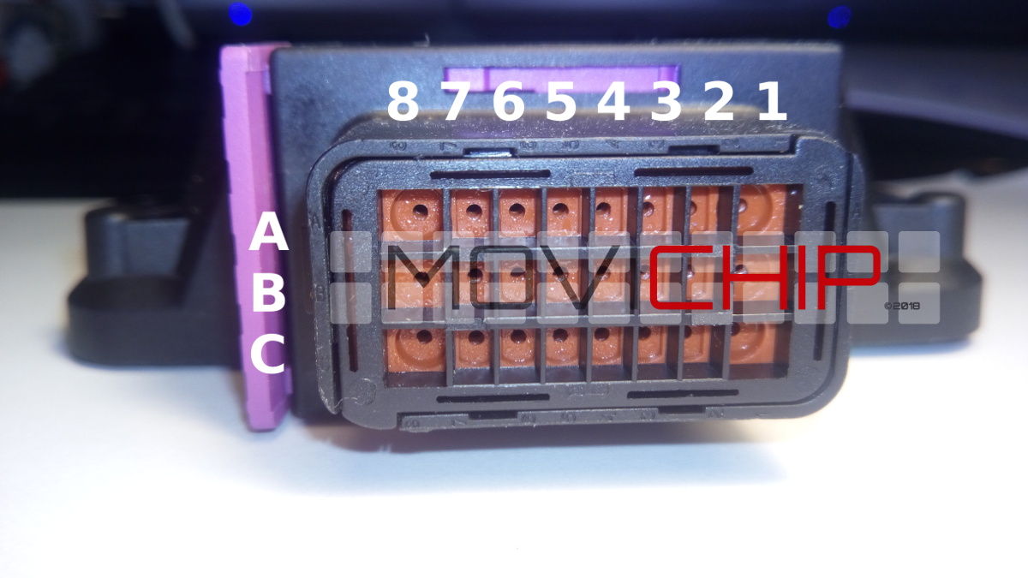
Figure 2 - Around the holes where we insert the wire the columns and rows are marked/indented into the plastic. Characters are small.
The RPM signal should alternate between 0 volts and 5 to 15 volts
Power inputs should be fused as detailed above.
Knock sensor should be connected directly to KSC and not spliced to other ECUs. If knock sensor signal is spliced to other ECUs it may cause interference and improper functioning and detection of knock.

KSC is supplied with:
The KSC control/detection unit
Connector and crimps terminals. User makes their own wiring loom.
Instruction manual can be downloaded from the MoviChip website, it is not sent with the product.
The Android app can be downloaded from the MoviChip website.

The KSC Android App
The Android app is where we program the KSC unit.
To setup the unit:
1.We calibrate the knock sensor input and RPM signal
2.We prepare the unit for the Knock ID and Baseline tools
3.Identify the knock frequency. We use the Knock ID tool to identify/confirm the knock frequency, as read by the knock sensor, for the specific engine
4.Identify baseline volume. We use the Baseline Configuration tool to identify the normal knock sensor signal volume when engine is not knocking.
5.We confirm our settings are not outputting false positives and we confirm our settings are not missing knock events. If unit is not identifying knock to the accuracy required, we tune our settings (knock frequency window monitored and/or volume threshold) to achieve accuracy required.
The steps below are listed in order.
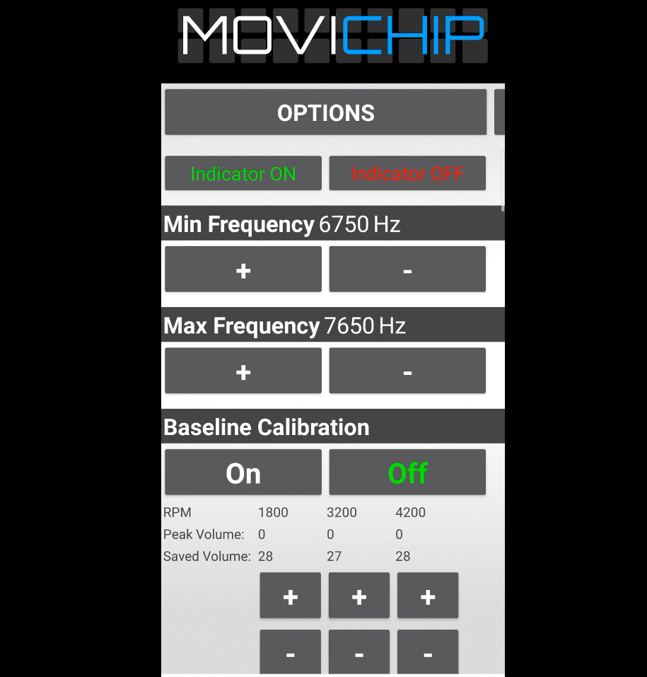
Figure 3 - A snap shot of the KSC Android app

Sensor Inputs
We need to calibrate the sensor inputs. We can see live sensor reading by opening the Baseline Menu and pressing "On"
If we simply want to populate the stored values already in the unit we press "Off"
NOTE: Pressing On will reset the RPM points. A new calibration run will need to be done. For this reason it is recommended only to check the RPM when first setting up the unit and before a calibration run is done. Setup procedure is detailed below.
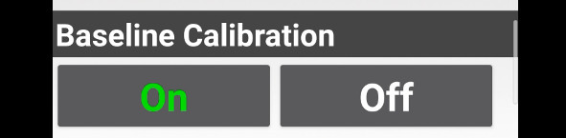
Figure 4 - Press "On" on Baseline Calibration to see live RPM and Knock Sensor signals.

RPM
Are we getting one signal per revolution on our RPM signal or 0.5 (1 signal every two revolutions of the engine). We enter the number.
This signal should alternate between 0 volts and 5 to 15 volts.
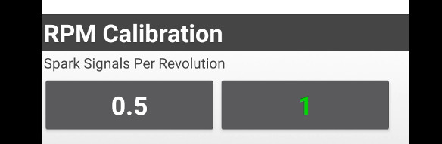
Figure 5 - Number of signals we get per RPM

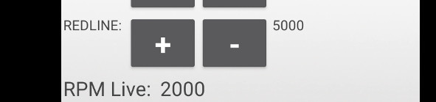
Figure 6 - We can verify RPM is correct here. Open Baseline by pressing "On" and check the "RPM Live" number. NOTE: Pressing on will reset the RPM points. A new calibration run will need to be done. For this reason it is recommended only to check the RPM when first setting up the unit and before a calibration run is done. Setup procedure is detailed below.
.

Knock Sensor Signal Gain
We want to process the highest possible number. If we see the Knock Sensor Live number is less than 200, we can increase the Signal Gain to "2".
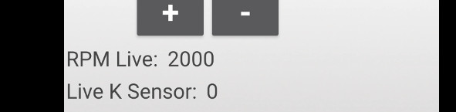
Figure 7 - If the "Live K Sensor" number peaks at less than 200 in normal driving we can increase Gain to "2"
Figure 8 - Increase signal gain if possible

Setting Up The Unit
Before we can use the inbuilt apps to identify the knock frequency and volume we need to choose some settings.

RPM
We need to choose a mid RPM and the redline RPM. Redline RPM is self explanatory. It is recommended to choose an RPM slightly lower than redline eg if redline is 7000rpm, redline could be set as 6500rpm. Mid RPM point will be somewhere around 50% of the rev range. If the engine has an 8000 rpm redline, we set this value to around 4000 rpm. You can adjust these RPM numbers to suit your preferences.
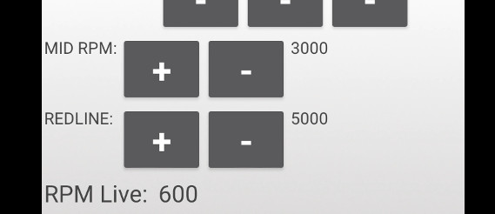

Save Volume
This is the knock volume threshold. During the set up process we want to be able to hear engine knock without the KSC interfering. We can either disconnect the KSC from the ECU and/or we set the Saved Volumes to very high numbers.
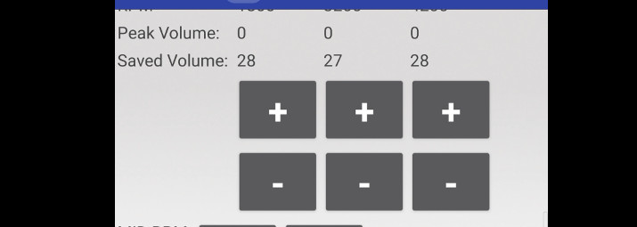

Knock ID
To identify knock we first must know the knock frequency. There are two methods to find the knock frequency. The first is to use a Knock Frequency Calculator and then verify that frequency using an audio knock frequency detector.
The second method is to use the Knock ID tool inside the KSC Android app.

How to use the Knock ID tool.
1.Set a conservative ignition timing over an RPM band. We suggest 2000-3000rpm. We want the ignition timing at this RPM band to conservative so we can guarantee that the engine will not be knocking at high/full load.
2.Record the volumes of the knock frequency bands by driving with a high/full load between 2000 and 3000 rpm. We record the runs by pressing "On" on the app.
Press "Off" on the app to stop recording.
We want to stop recording before the throttle is lifted.
3.Repeat this process 3-5 times. At the end of each run, when pressing "Off", the tool will output the frequency segments and the maximum volume recorded.
NOTE: There will be a delay of around 3 seconds between pressing "Off" and the list being populated
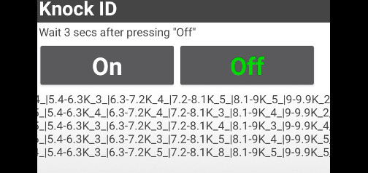
Figure 9 - Knock ID output. Each line represents one run.
4.Repeat the process, without switching the engine off, but this time with the ignition timing advanced to cause slight, non damaging knock between 2000 and 3000 rpm.
5.Look through the runs and identify the frequency segments whose volume has changed between the runs with retarded ignition and advanced ignition timing. This will indicate the knock frequency of the engine. This will normally be close to the theoretical knock frequency of the engine.
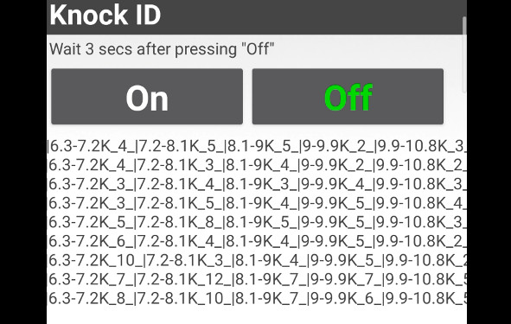
Figure 10 - Comparing runs with ignition timing retarded vs advanced. 6.3-7.2K & 7.2-8.3K have jumps in volume. Theoretical knock frequency is 7.2k. We will set frequency window at 6.7k minimum and 7.6k maximum.

Setting the Knock Frequency
When we have identified the knock frequency we need to enter the values into the app.
Minimum and maximum frequency should match the frequency segment found using the Knock ID tool. It is recommended to give a broad frequency range until you are familiar with the product.
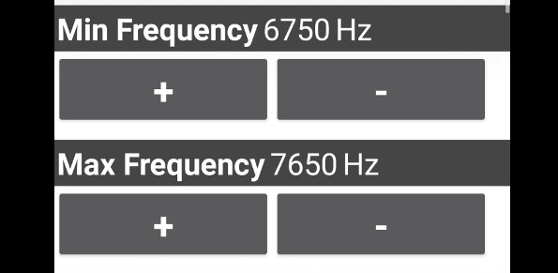
Figure 11 - Setting the knock frequency window to be monitored

Setting the Knock Volume Threshold
To set the threshold we need to know what is a normal volume for the engine. We measure this using the Baseline tool inside the app.
1.Set a conservative ignition timing map for high/full load for the entire rev range of the engine
2.Press "On" in "Baseline Calibration". Do a run from 1000 rpm at high/full load to redline rpm. Record the run by pressing "On" and finish recording (before lifting the accelerator) by pressing Off. This will output the peak volume at three RPM points through the rev range. The RPM points are drawn from the mid-point and redline RPM numbers we entered earlier.
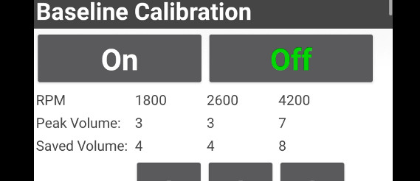
Figure 12 - Baseline output shows max volume @ 1800 RPM as 3, 2600 RPM as 3 and 4200 RPM as 7. We set out thresholds (Saved Volume) just above these values.
3.We set the Saved Volume to numbers slightly higher than the peak numbers we have just recorded.
4.We should verify the thresholds we have just entered by repeating the run (with the same ignition timing). We should not receive any warning signals coming from the KSC. If we do we should either tune the knock frequency and the volume thresholds we have entered.
5.When we are happy we are not getting false positives we return the ignition timing map back to a known good value. And we increase the ignition timing at a set RPM to induce slight knock. We then check that the KSC is detecting the knock by outputting the warning signals. If not, tune the threshold volume and or the frequency window we are monitoring.
The KSC is now ready to detect knock.
We can now close the app by pressing the red bar at the bottom. We only need to use the app again if we want to adjust the settings entered above.

