Intercooler Spray Manager (ISM)
Intercooler Water Spray Controller

Contents
Disclaimer 3
Introduction 4
Wiring 5
ISM is supplied with: 6
The ISM Android App 6
Sensor Inputs 7
RPM 7
Setting Up The Unit 8
Stage 1 8
Stage 2 9
Nozzle Spray Durations 10
Stage 1 10
Stage 2 10
Set Up Complete 10

Disclaimer

WARNING
MoviChip products should be used for motorsport and/or off-highway use only.
MoviChip products should only be used by persons who are experienced with automotive electrical and mechanical systems and the effects of altering such systems.
Misuse or improper tuning of MoviChip products can cause unexpected vehicle behaviour and/or failure (temporary or permanent) of existing vehicle systems e.g. limp mode, engine damage etc.
MoviChip products are universal. It is the responsibility of the end user to ensure MoviChip products are suitable for their specific application. MoviChip is not responsible for special, incidental or consequential damages or costs incurred due to the failure of this product.

MoviChip products are used entirely at the risk of the end user.

Introduction
The MoviChip Intercooler Spray Manager (ISM) integrates with an existing intercooler water spray kit to automate the spraying of the intercooler to achieve lower and more consistent intake temps while making the water last longer.
The MoviChip ISM uses two analog 0-5 sensor inputs and an RPM input (alternating between 0 and 5-15 volts, once every two engine revolutions or once every revolution) with user programmed thresholds to control the spraying of the intercooler.
The ISM uses two 12 volt outputs. The first output is intended to drive a pump which has an inbuilt pressure cut-off. The second output is intended to drive a solenoid to control the flow out of the water jets.
NOTE: The ISM is **NOT** designed to control the spray of water directly into the intake. The ISM is not a water injection product. It is solely for automating the water spray onto the outside of the intercooler.

Wiring
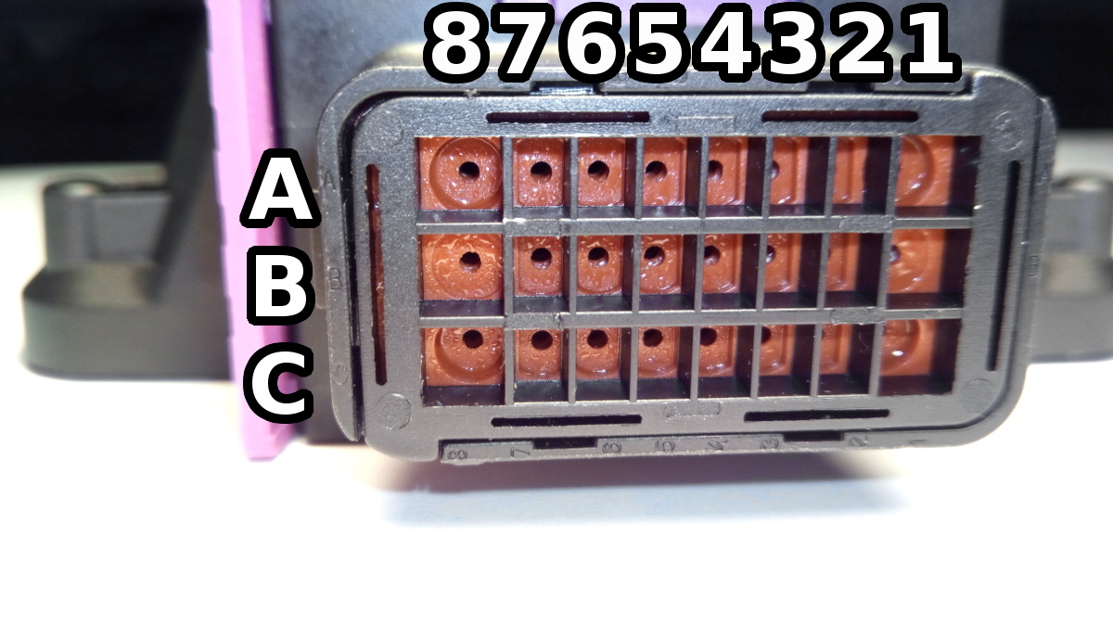
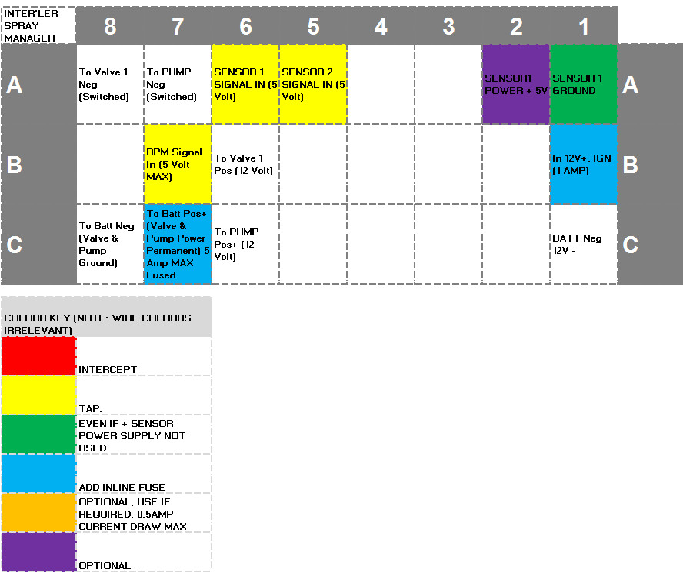
Figure 1 - Looking at connector from wiring/loom side. The connector is marked with letters and numbers as per the diagram above.
The RPM signal should alternate between 0 volts and 5 to 15 volts
Power inputs should be fused as detailed above.
PUMP connections are intended for water pumps with inbuilt pressure cut off. If the pump you are using does not have a pressure cut off, the pump must be triggered with the same circuit as the solenoid i.e. the pump must be energised at the same time as the solenoid. If this circuit will draw more than 5 amps use an external relay (not supplied) to power the circuits

ISM is supplied with:
-The ISM control/detection unit
-Connector and crimps terminals. User makes their own wiring loom.
-Instruction manual can be downloaded from the MoviChip website, it is not sent with the product.
-The Android app can be downloaded from the MoviChip website.

The ISM Android App
The Android app is where we program the ISM unit.
To setup the unit:
1.We calibrate the RPM input
2.We check the unit is wired properly by checking we the Sensor menu. In this menu we can see the output from the sensors and the live RPM.
2.We set the Stage 1 (Light Duty/Normal Driving) spray duty cycle threshold
3.We set the Stage 2 (Heavy Duty) spray duty cycle threshold

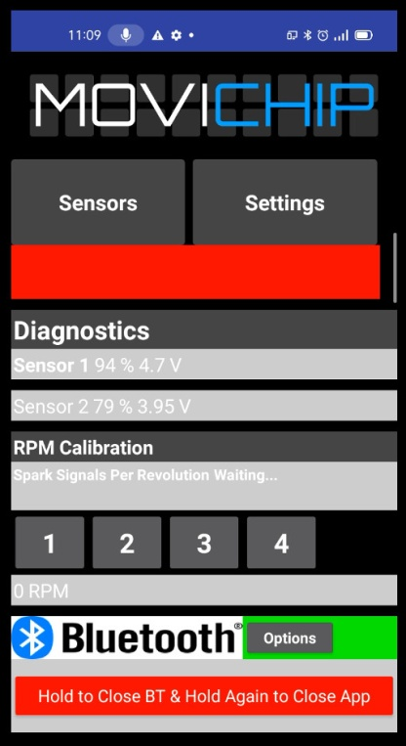
Figure 2 - A snap shot of the ISM Android app. This is the diagnostic menu, here we see can sensor values and RPM in real time.

Sensor Inputs
We need to calibrate the RPM input.
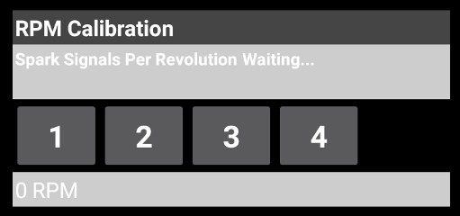
Figure 3 - RPM signals per revolution.

RPM
Are we getting one signal per revolution on our RPM signal or 0.5 (1 signal every two revolutions of the engine). We enter the number.
NOTE: This chosen RPM signal should alternate between 0 volts and 5 to 15 volts.

Setting Up The Unit
To set up when and for how long the nozzles will spray our intercooler, we need to set the thresholds. We have two thresholds, one which dictates the spray during normal driving and one threshold which dictates the spray under high load.
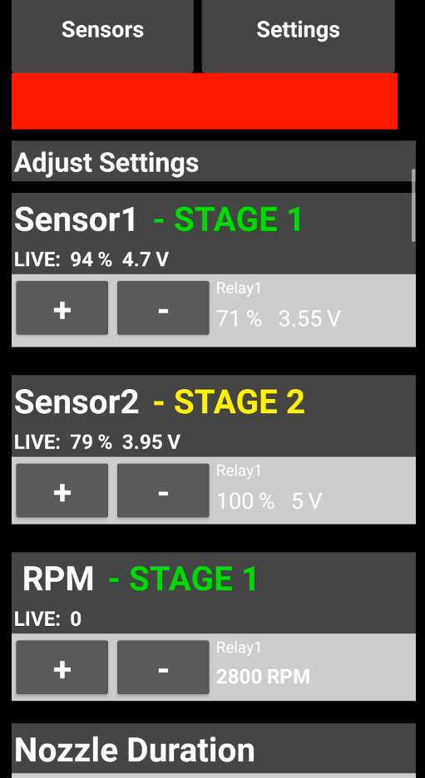
Figure 4 - An overview of the settings menu in the ISM app.

Stage 1
For Stage 1 we choose the Sensor 1 threshold value and the RPM value.
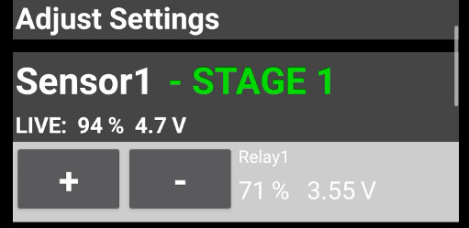
Figure 5 - Setting the Stage 1 Threshold. We set the Sensor 1 threshold and....
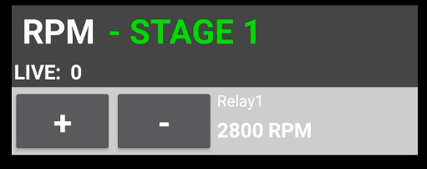
Figure 6 - ... and the RPM threshold

Stage 2
The Stage 2 Threshold is simply adding another value to the Stage 1 Thresholds. For example the Stage 1 threshold is set at 50% of the Sensor 1 (e.g. MAP sensor) signal and 2000 RPM, the Stage 2 Threshold would use the same values plus add an additional Sensor Threshold e.g. TPS over 80%. When the conditions are met for Stage 1 and TPS is over 80% we get the Stage 2 nozzle spray duration.
You could use the same sensor signal for Sensor 1 and Sensor 2 if you wish.
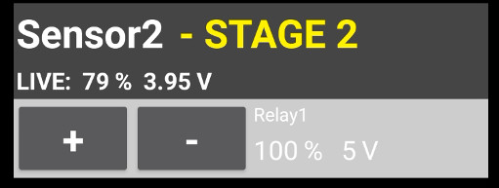
Figure 7 - Stage 2 uses the thresholds from Stage 1 plus one extra sensor value.

Nozzle Spray Durations
When we have set our thresholds we need to set the nozzle durations for each "stage"
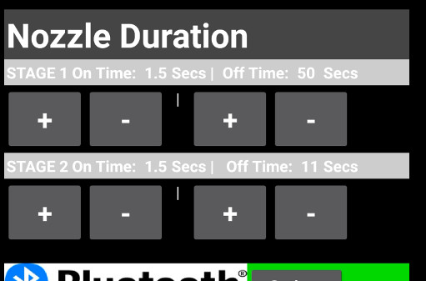
Figure 8 - The Nozzle Duration section of the settings menu.

Stage 1
In this example we can see that the Stage 1 nozzle duration is 1.5 seconds of spraying followed by an off time of 50 seconds. When the Stage 1 thresholds are exceeded, this is how often the nozzles will spray for. Note: When the Stage 1 thresholds are not met, the timers stop. Time is only counted when the threshold is exceeded. We pause counting the 50 seconds (from Figure 8) when thresholds are not met. Stage 2 works in the same way.

Stage 2
When the Stage 2 threshold is exceeded in this example, the nozzle will spray for 1.5 seconds and the off time between nozzle activation will be 11 seconds.

Set Up Complete
The set up of the ISM unit is now complete. You can disconnect the app from the unit. You only need to connect the app to the unit again if you want to change the settings. The ISM will run in the background spraying the intercooler, you just need to refill the water.

